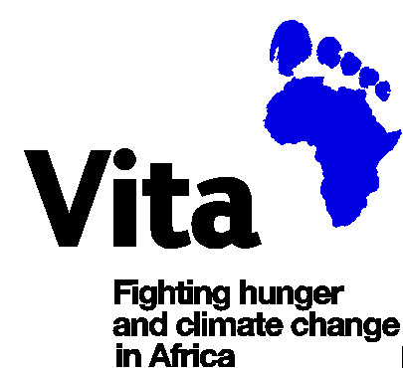

Vita Strategic Plan 2016

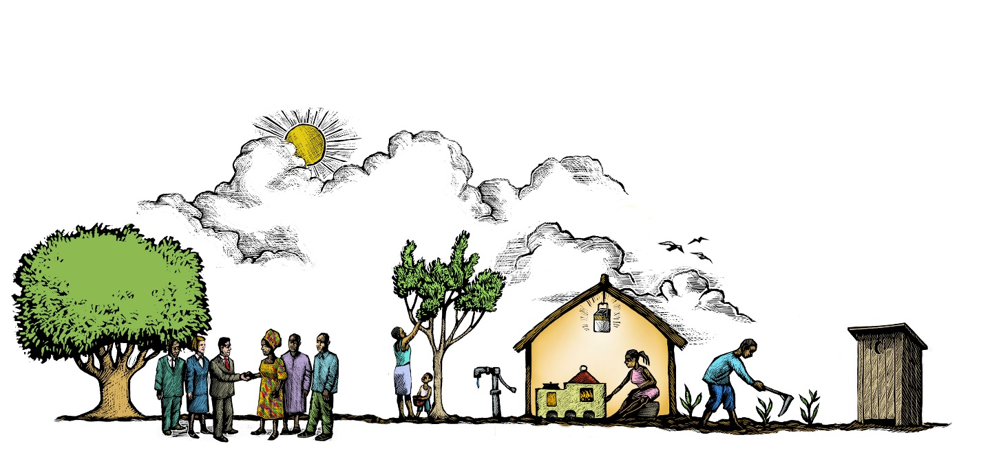

Vita Strategic Plan Contents
- Introduction

- Our Organisation

- Our Vision
- Our Mission
- Our Values
- Our Strategic Direction
- Our Programme Goals
- Our Programme Strategies

- Our Programmes

- Our Development Approach
- Our Operational Strategies
  - Targeting
  - Partnerships
  - Innovation
  - Learning
  - Irish Public Engagement
- Goals and Outcomes
- Delivering, Monitoring and Reporting our Results

- Developing the Organisation

- Our Organisational Objectives
- Our Organisational Strategies
- Governance and Policy Development
    - Policies
    - Risk Policy
    - Finance Policy
    - Audit Policy
- Funding Strategies

Annex 1 – Programme, Funding and Organisational Plans 2016-2020 - Key Measurables
Annex 2 – Vita’s Alignment with the Global Goals for Sustainable Development

- Introduction
Vita is an Irish non-governmental organisation (NGO), which was established in 1989 in order to offer support to refugees who were escaping from famine and conflict. During the 1990s the organisation evolved to focus more on addressing underlying causes of poverty and displacement. This process accelerated as Vita focused on contributing to the achievement of the Millennium Development Goals (MDGs) - a number of which have essentially been achieved, most notably the targets around poverty and to some extent hunger. In that global context Vita plays a modest but increasingly significant role through its strategic focus on hunger and climate change. Globally, poverty has halved since the launch of the Millennium Development Goals in 2000 and many of the least developed countries have experienced steady economic growth and improved human development.
However, this economic growth has been uneven and unequal and there has not been a commensurate reduction in the numbers of people who are living in extreme poverty. In the Horn of Africa, where Vita works, the majority of rural communities continue to lack access to basic services such as clean water, good sanitation and electricity. While access to health and education services has grown substantially, access to financial and livelihood development services has lagged behind. In particular, women and girls continue to bear a considerable burden both in maintenance of the household and in food production. Labour saving technology both on and off farms is low and, critically, women’s access to property and technology is especially low.
Hunger continues to persist, particularly for women and children throughout sub-Saharan Africa and notably in Vita’s two programme countries of Eritrea and Ethiopia. Ongoing adverse climate change and erratic rainfall are creating further food insecurity as well as degrading environments. At the same time, due to population increase, land holdings are diminishing to well below economic size. Although literacy rates have progressively increased, rural smallholders do not have access to the knowledge and technologies that would enable them to increase productivity or to diversify food production. In Ethiopia and Eritrea, approximately half of rural people still do not have access to clean water, with less than a quarter having access to good sanitation. Only a quarter of the Eritrean and Ethiopian populations have access to electricity or an improved cooking source, with most relaying on biomass. Poverty and hunger drive outward rural migration amongst the young, especially men, leaving as many as one third of households now female-headed.
Over the past decade and half since Vita shifted strategic focus, we have developed a range of strengths that have propelled us towards becoming a key development actor in the areas where we work. In fact, Vita is one of a very small number of NGOs working in Eritrea. We have continued to evolve our strategic focus and, in addition to helping strengthen the resilience of rural households, we are also committed to innovation, continuing to update our approaches to the development processes in which we are engaged. Vita’s focus is to work with such rural households in Ethiopia and Eritrea so as to enable them to harness scientific and technological innovations to transform their homes, farms and environment and thus allow them to lead happy and fulfilled lives within their own communities.
In setting out the strategy for the future we are not only guided by our ongoing learning and increasing organisational expertise, but also by the learning and analysis of other important actors in the sector, not least the governments of both Ethiopia and Eritrea. Our programme objectives will be coherent with the Sustainable Development Goals (SDGs), which were launched by the United Nations in September 2015 as well as the Paris Agreement 2015, as outlined by COP 21 and the OECD Rio Markers on Climate Change.

- Our Organisation

Our Vision
Thriving rural economies in Africa with access to services, markets and livelihoods for all
Our Mission
To reduce poverty, hunger and inequality amongst rural households through knowledge-backed, community-led initiatives leading to sustainable livelihoods
Our Values
Vita’s work is grounded in four core values

Inclusion
We take a whole community approach and strive for all households in the communities where we work to have access to services, technologies and skills through our programmes.

Enablement
We work together with local communities to ensure that our support builds on existing local knowledge and community expertise, thus enabling people to have more control over their livelihoods.

Sustainability
We seek to ensure that tangible benefits accrue which endure beyond the phase of direct support from Vita, without subsidy or dependency and without draining natural resources.

Accountability
We are committed to ensuring that we are fully accountable to our intended beneficiaries and to all other stakeholders for our agreed commitments, and for the quality of our programmes and the results achieved.

In the 2016 -2020 period Vita will review the adoption of core values in the organisational culture and monitor how core values have been reflected in initiatives and practical measures.
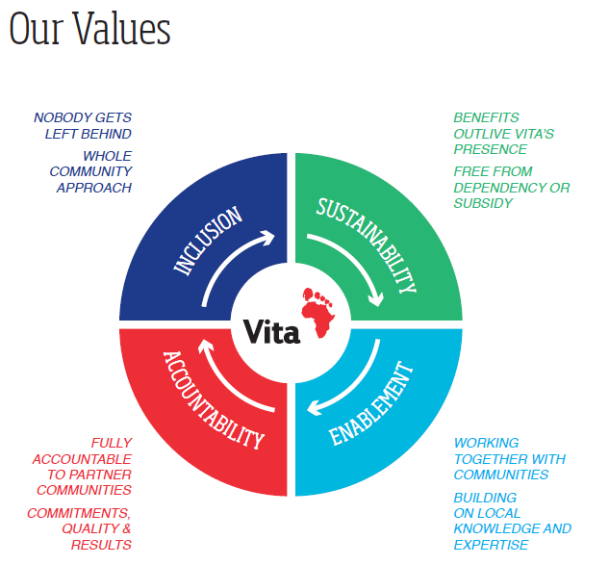

Our Strategic Direction
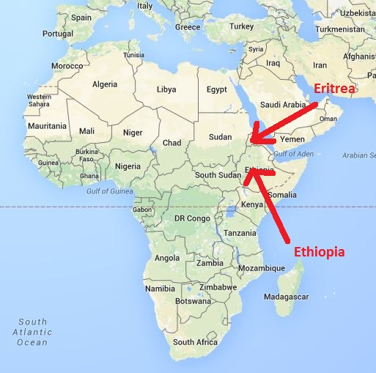
- Community programme work will continue to be focused on knowledge backed agriculture, with potato as a particular focus area. There will be an increased focus on household energy and on water and sanitation.

- Vita will build on strategic initiatives and use innovations and robust evidence, emanating from community programme work, to expand our scale and influence. This will include leadership in cross-country collaborations of government, development and business sectors, e.g. through the Irish Potato Coalition and the Vita Green Impact Fund (VGIF)

- This ambition must be underpinned by stronger core competence, systems and management both within the programme countries and between the programme countries and Ireland. Building a stronger organisation will be achieved through strategic staff recruitment and training, and support from a highly engaged board.

- Vita will consolidate our programme presence in Ethiopia and in Eritrea. We will establish an indirect presence elsewhere through funding and supporting local partners in other countries in Africa, and possibly more widely through the VGIF.

- Vita will look to grow progressively and sustainably at approximately 20% annually which would more than double our total income by 2020. Such growth will depend on establishing enduring and more programmatic donor partnerships and income sources, which fit with our programme focus. We will also seek to augment our grant funding with investment funding, sourced through initiatives such as the Vita Green Impact Fund (VGIF), with a target of 30-50% of annual income through investment by 2020

- Vita will seek a wider presence in developed countries through direct and indirect presence in the UK, USA and Italy. This is intended to broaden the fundraising base, particularly related to investment funding, and also to advance the goal of increased scale and influence.

Our Programme Goals

Vita’s five-year strategic plan is focused on achieving two programme goals and two organisational objectives. The organisational objectives are the enablers for attainment of the programme goals. Therefore, to reflect the centrality of our programmes to Vita’s vision and mission, our programming goals and strategies are set out ahead of our organisational objectives in this Strategic Plan.

Programme Goal 1
To improve food security and resilience for resource-poor rural households

This goal drives all of Vita’s direct work in support of rural households and communities in Africa. By food security we mean that rural households have sustainable access to sufficient nutritious food for active and healthy lives. By resilience we mean that rural households will have access to the basic means to be able to cope with the ongoing challenges of climate change, environmental degradation and general lack of resources.

Programme Goal 2
To scale and influence positive change to development practice for resource-poor rural households, and to combat climate change.

We believe that Vita has a key role to play in the world beyond the direct work with rural households and communities and we will bring this wider intent to all our work. Vita will broaden our influence firstly by generating robust evidence of change brought about by well-documented innovation. We will engage in partnerships both in-country and between countries, and will bring additionality by sharing resources and knowledge within the wider sector.

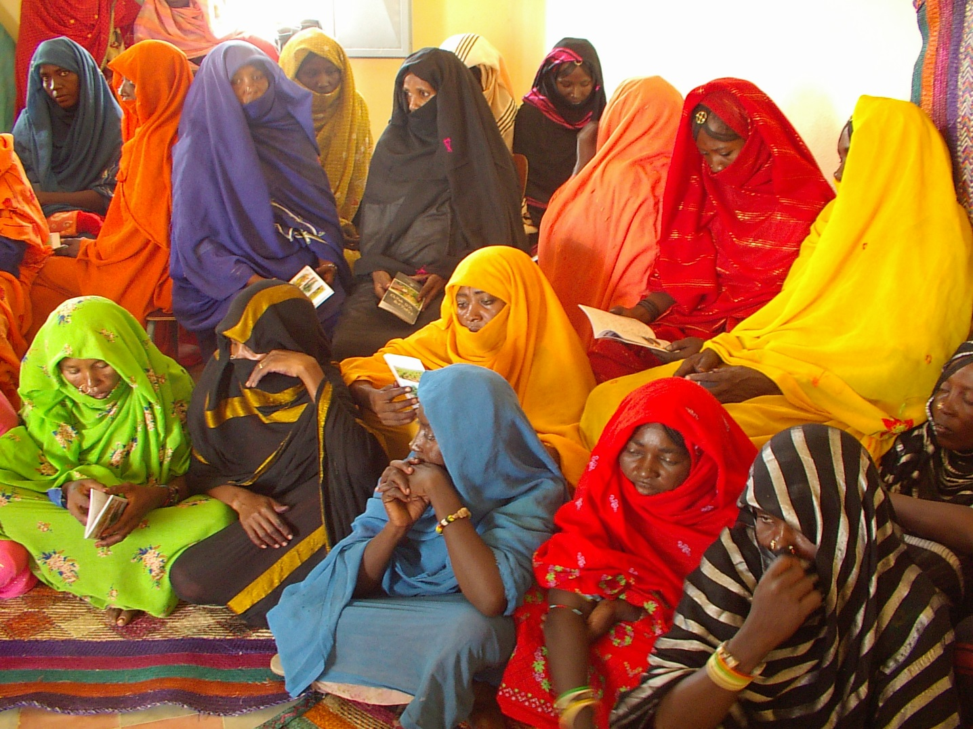

Our Programme Strategies

Vita will pursue four high-level strategies towards achievement of the two programme goals:

- In Eritrea, to consolidate our knowledge agriculture partnership with the Ministry of Agriculture, Teagasc and Gorta SHA, as well as extending Irish partnerships to energy and water.

- In Ethiopia, to build “Community Led Green Zones” starting with the Gamo Gofa Zone and to use data and evidence to extend community led programing. We will also seek to advance the Ethiopian Potato Coalition.

- In at least two new countries, to develop local partnerships to deliver sustainable energy and water to communities, to be financed by the Green Impact Fund.

- In Ireland, to extend our agriculture and other research partnerships to improve our programme quality, so as to build a stronger evidence base, better community participation and influence policy.

- Our Programmes

Our Development Approach
Vita believes that the realisation of sustainable change can only be achieved by ensuring that the target communities, with whom we work, are centrally involved in decision-making and implementation processes. Therefore, our approach to our work ensures that all households in those communities have equal opportunity to participate in consultation and planning processes, as well as having access to the services, technologies, resources and knowledge that are facilitated by Vita in response. We see our work as being both community-led and knowledge-backed.

Vita works with rural people in Africa who experience structural poverty and food insecurity, many of whom are emerging from aid dependency. Within those communities, we will continue to focus at the household level, with an emphasis on agricultural activities associated with maintaining such households. We see the provision of new farming technologies and techniques, which enable diversification and improved productivity, as being central to improving access to a more abundant and diverse food range, thus reducing the risk of hunger and/or malnutrition. We have therefore identified knowledge-backed agriculture as a central plank of our programming.
Vita has a good understanding of the role played by women in rural African communities, and many households with which Vita engages are headed by women. We understand, however, that the concept of gender roles in the household around decision-making and control is a complex one. We are acutely gender sensitive in our community-led approach, which is fundamentally about working optimally with both genders in fighting hunger. However, we will continue to emphasize our commitment to the enablement and empowerment of women, given their critical role within the household.

Vita works in two countries where governments exercise tight political and economic governance and which have strong structures and networks right down to the village and household levels. Such structures and networks present good opportunities for Vita to engage with the local agricultural sector as well as with other local networks. Vita also believes that we can play a role in influencing local government approaches to supporting local communities, which benefits people and communities well beyond Vita’s areas of direct influence. Therefore, we believe Vita’s partnership with government supports our commitment to optimising our opportunity to influence others and to scale up the impact of our work.
Through partnerships and close engagement with national, international and Irish agriculture and energy organisations, as well as with funding partners, such as Irish Aid and the European Union, we create further platforms for influence.

Our approach to improving the lives of poor people occurs at two levels – one being Vita’s direct programmatic interventions in Ethiopia and Eritrea and, secondly, through Vita’s capacity to influence others in their efforts to bring about positive sustainable change. This understanding of how change happens, which is diagrammatically represented below, underpins Vita’s strategic approach, as presented in this plan.

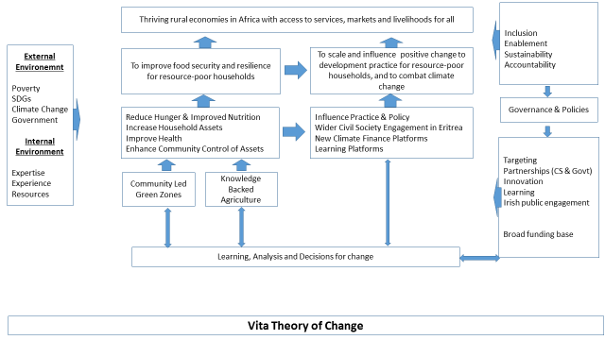

Our Operational Strategies
In order to strengthen Vita’s potential to achieve our stated goals and objectives we have developed a series of important strategies that provide a framework within which to operate. Two of the strategies below, Targeting and Partnerships, are further elaborated within fully developed policies, which form part of Vita’s range of organisational policies (listed on page 18)

- Targeting

For all of our programmes we will define and agree a targeting approach with our local partners. We will continue to target poor rural households in Eritrea and Ethiopia and apply our core competence and experience in fighting hunger and climate change. We aim to work with communities that are dependent on resource support, such as Poverty Safety Net programmes and government food assistance programmes prevailing in Ethiopia, but also those depending on foreign remittances as is widespread in Eritrea.

Within these communities our targeting will be influenced by the programme activity, i.e. community-led green zone or knowledge-backed agriculture. For community-led work, our approach is based on our Community Led Total Sanitation (CLTS) experience and is an inclusive “leave no one behind” approach in which all households are included. For knowledge-backed agriculture we will target households in different wealth categories. In some instances, it will be necessary to work with already productive farmers, for example, to ensure a sustainable good quality seed supply for utilisation by resource poor households. However, Vita will build elements into programme activities which ensure some level of access, particularly to seed for resource-poor farmers. In both of the main programme activities - at the household level - we will actively engage with women, given that women are the recognised primary agents for change in African households.

In its selection of beneficiaries, Vita will ensure that our targeting approach is coherent with our programme goal relating to improved food security and resilience for resource-poor households. This requires that low-wealth households are predominantly targeted and are always the essential focus of our ongoing enablement of households with which we work.

As part of our Vita Green Impact Fund (VGIF) initiative, we will seek to establish carbon credit projects beyond our two programme countries. This will serve to prove our ability to deliver a project in another country using a local partner, without the need for establishing an office there. However, Vita’s overarching targeting policy will still apply.

- Partnerships

Vita engages at all levels from micro level for service delivery amongst direct target communities to macro level for scaling and influence in international collaborations and fora. We will engage with a wide range of partners who can add value that ultimately enhances our service delivery capacity in support of food insecure households in our programme countries.

We consider the Ministries of Agriculture in both Ethiopia and Eritrea as core partners in promoting sustainability at community level, and in creating a wider impact through their promotion and replication of good practices elsewhere in the respective countries. We also work through, and with, a range of other partners both in-country, in Ireland and internationally as part of our strategy to influence the international development sector. We will further increase our level of strategic collaboration with such partners during the period of the plan. In the formulation of country strategies, Vita will also conduct detailed analysis of how partnerships, particularly government partnerships contribute in terms of delivery of goals, effective targeting, and influence on policy and practice vis-a-vis resource poor communities.
We have an active partnership with communities (micro level) which is reflected in their engagement in project implementation by community project steering committees. We will further build on these partnerships as we enter into long term climate change projects, of up to seven years’ duration, with communities whereby communities exchange future carbon credits for provision of materials and services

We believe that partnership with local government (meso level) is fundamental to a sustainable development and we will continue to work closely with local government while always maintaining our values, policies and guidelines. We will continue to structure this through programme agreements (MoUs) which engage local government at different levels and disciplines.

We believe in the important role for local civil society partnerships (meso level) in service delivery, in creating local capacity for sustainable development and in building a voice for civil society in influencing its own development. In future, we will move from short term partnership support to actively forming strategic long term partnership agreements with cooperatives and local development agencies.

Based on the success of integrating research into our work we will continue to strengthen linkages with our knowledge partners (macro level), both locally (national research agencies, universities) and internationally (Teagasc, CIP, universities).

Over recent years we have experienced the benefit of closer partnership with peer NGOs and we will seek to create further programme and strategic partnerships.

- Innovation
Vita has worked closely with science and research institutes since 2011 and created innovative models such as the Potato Centre of Excellence in Ethiopia and the Teagasc research partnership and Gold Standard carbon programme in Eritrea. Vita will apply more structure to innovation models in the 2016 – 2020 period drawing on existing and new research partnerships but giving more focus to the conversion from research and data into the development of adaption technologies for climate-smart agriculture as well as energy. Some key areas of innovation, which Vita will focus on, and the related knowledge partners, are outlined in the table below:

Programme Area | Partner | Innovation
Community Led Green Zone | Cardiff University Research Network | Measuring impact in innovation
 | CLTS Foundation | Community led energy and agriculture development
 | Gold Standard | Climate and carbon finance
Knowledge Agriculture | Teagasc Research and Innovation | Potato and Dairy Models  Minimum Household Package  Agriculture Knowledge & Innovation Systems (AKIS)
 | Ethiopian Agriculture Transformation Agency  Eritrea National Agriculture Research Institute | Seed Sector Development

The focus areas for innovation, which include both product and process innovation, each have very substantial scaling potential. Research partnerships with Teagasc and Cardiff University will strengthen our ongoing programme monitoring capacity with their application of data collection technologies, data interpretation and publication of findings. Having access to such comprehensive data will enhance Vita’s potential to scale up successful innovative approaches it adopts. Collaborative models that Vita has already put in place, such as the Irish Potato Coalition and the Green Impact Fund, are already being used to disseminate learning from ongoing innovation around potato and carbon finance. In Eritrea we will also leverage growing partnerships with state partners such as the Eritrean Ministry of Agriculture and non-state partners such as Gorta Self Help Africa.

- Learning
Vita will continue to evolve into a structured learning organisation in the 2016 – 2020 period. Learning is a two-way process and Vita will use existing partnerships to build our own organisational learning and also bring learning to the sector in our areas of core competence. We will also continue to invest in postgraduate research to underpin our learning and innovation.
In both programme countries as an integral part of results based management, Vita will also work with existing partners to enhance learning in key programming areas and processes. The table below outlines those key areas:

Programme Area | Learning Partner | Learning Area
Community Led Green Zone | CO2Balance | Carbon accreditation and marketing
 | Int. Ins. for Ec. Dev. | Green Economy Coalition
Knowledge Agriculture | CGIAR CIP | Seed potato systems RBMS
 | Gorta SHA | Impact assessment
Climate Knowledge | Irish Aid Climate Learning Platform | Climate Mitigation through climate-smart household energy and agriculture

In relation to dissemination of Vita’s own learning, we consider it to be a specific strand of programming linked to scaling and influence as outlined above. Vita will place greater emphasis on doing this in collaboration with our learning partners with the objective of:
- Bringing best practice into programmes
- Applying lessons learned across the organisation and into future projects
- Sharing learning with the wider sector in Ireland and globally
- Scaling up best practice

Over the period of the plan Vita will conduct workshops to analyse and reflect on findings and analysis from postgraduate research that will be commissioned to support our ongoing learning. Such fora will instruct Vita’s future programme work on potato and dairy, cook stoves and carbon finance, and will generate sound learning and beneficial collaboration for scaling up and policy influence. Vita will continue to facilitate learning events in Ireland and overseas as a key part of its strategic approach.

- Irish Public Engagement

Vita will continue to build on our existing strategy of partnering with networks of our agricultural, energy and other constituencies in Ireland. We will communicate through these partners as well as through our own network and established platforms to spread our message, educate on issues regarding poverty and climate change, and encourage support. To maximise engagement we will seek to align our messaging to relevant key influencers in those constituencies.

We will look for opportunities to continue engagement with the public by utilizing the existing outreach infrastructure of other value – matched organisations.

A new approach is to explore how to engage with a wider public, focusing messaging on climate change and hunger using digital platforms that showcase our work programme and the work of our stakeholders and supporters.
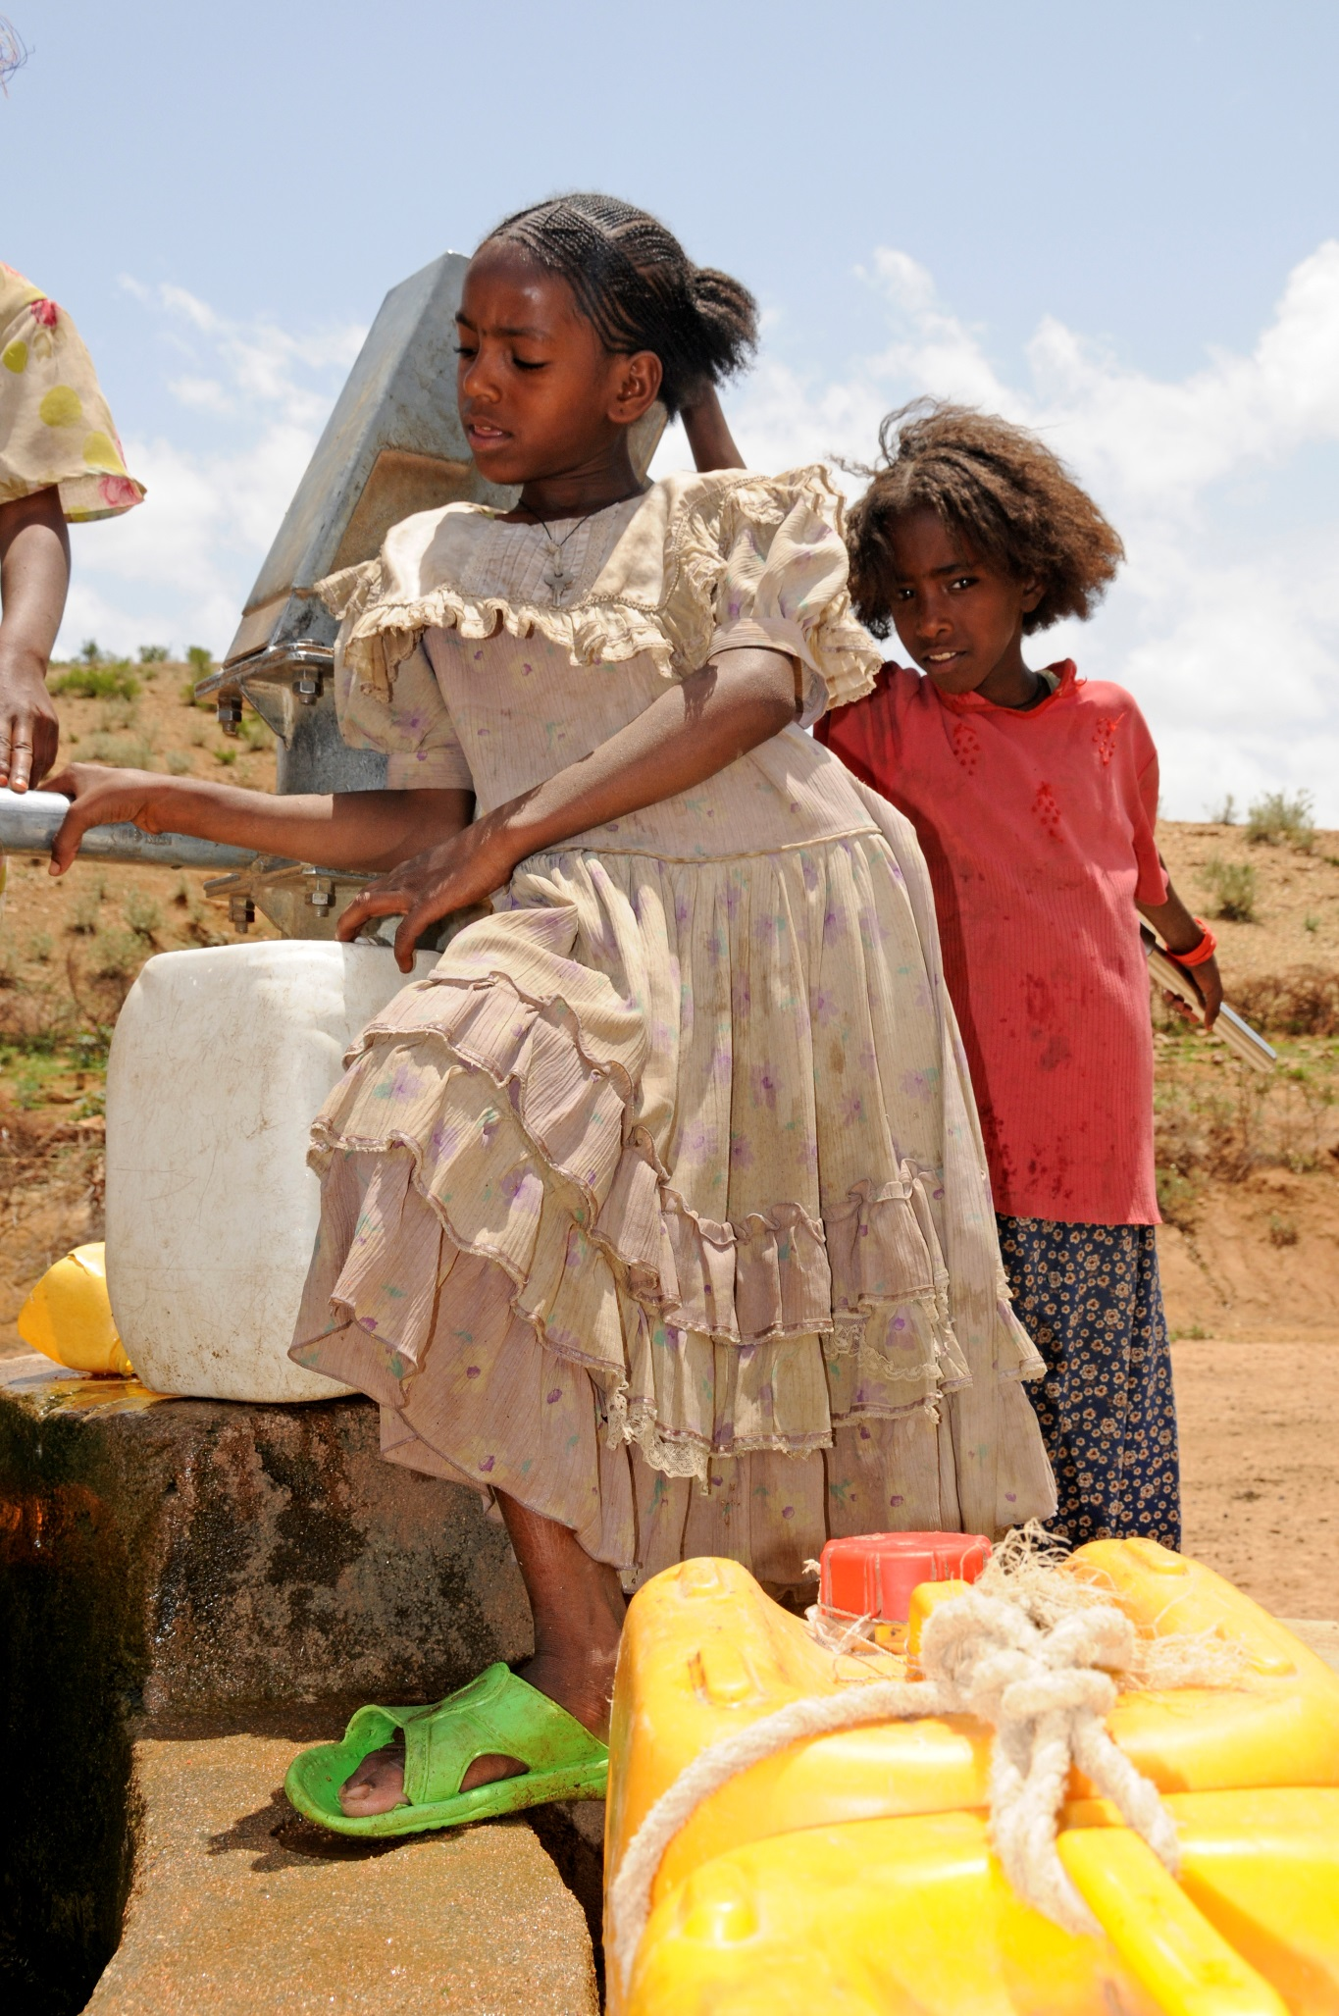

Our Programme Goals

As noted earlier in this document, Vita has set out two Programme Goals that will be its primary focus over the period of the plan.
Our first goal - To Improve Food Security and Resilience for Resource-Poor Rural Households - will be achieved through our work with Community-Led Green Zones and Knowledge-backed Agriculture
Our second goal - To bring positive change to development practice for resource-poor rural households, as well as to fight climate change - will be achieved through our commitment to scaling and Influence.

Vita will expand our work on household energy, and water and sanitation as key resilience-building blocks on the pathway to food security. We will also broaden the community led total sanitation approach into community led energy and agriculture development to enable greater local ownership and inclusion and we will back our agriculture work with research and document results again through research. We will better understand and integrate our household energy, water and sanitation and food security work to strengthen pathways to sustainable improvements.

Goal 1: To Improve Food Security and Resilience for Resource-Poor Rural Households

Core Activities

Community Led Green Zone Development- meaning Vita’s community led approach to community water supply, household energy and natural resource management to create what we call “community led green zones”

Household Energy
Vita utilises the community led approach for the dissemination of environmentally friendly and cost-effective cook stoves, and will now extend this engagement through dissemination of solar lights in conjunction with Community Led Total Sanitation (CLTS)
Water and Sanitation
Vita will continue to work with communities in the development of new CLTS programmes. However, we are also committed to staying with the communities to support them in the ongoing maintenance of the CLTS infrastructure. Universal access to water and sanitation is a vital pathway towards sustainable livelihoods and Vita will require communities to demonstrate leadership of their development by obtaining certificates of “Open Defecation Free” status as a way of ensuring that communities actively participate in the process and have ownership over it.
Natural Resource Management
Vita has worked with communities on forestry enclosures and afforestation and soil and water conservation. Vita will use the community led approach to support communities in tackling issues pertaining to the soil, water, energy and forest resources in an integrated way so that the entire ecosystem is addressed. We call this an integrated management system approach. This is a natural widening of the household focus on water, sanitation and energy interventions, thus building on community mobilisation to sustain and harness the natural resource to create income and employment.

Knowledge Backed Agriculture - meaning Vita’s approach to introduce agriculture innovations through new technologies and practices to communities focusing on household farm systems, seed and crop production and value chain development. Emphasis is given to empowerment of poor rural households, particularly those that are headed by women. Vita seeks inclusion in productive agriculture as a key factor in households becoming resilient for the medium and long term. As part of this approach, Vita will create linkages with developing markets and value chains.

Household Farm Systems
Vita’s strategic focus will continue to be on extremely poor farming households, many of which female headed, in order to promote a more diverse and nutritious family diet, as well as to support small-scale income generation. Such interventions will include household dairy, vegetable gardens, poultry and beekeeping

Seed and Crop Production
Vita will focus on seed technology packages as the key to farm productivity and diversification. Our emphasis will be on developing community seed multiplication systems and seed cooperatives. We will also focus on crop production, protection and storage using community-led methodologies for ownership and inclusion. Climate smart agriculture, incorporating the smart use of water, will be a recurrent theme. Key crops will be potato, hybrid and highland maize, wheat and cash crops such as beans.

Cooperatives and Value Chain development
Vita will take a market-based approach to building commercial farming based on staple as well as high-value cash crops. We will work with both primary and cooperative unions to maximise market access and margins. Focus crops will be mango, apple and potato. Attention will be given to micro-finance, insurance and other drivers of value-addition.

It is expected that Vita will achieve a number of outcomes in its realisation of its first goal. The key outcomes to be achieved are:

- Reduced Hunger and Improved Nutrition
- Improved Household Assets
- Improved Health relating to air pollution and water contamination
- Enhanced Community Control of Assets

Goal 2: To scale and influence positive change to development practice for resource-poor rural households, and to fight climate change

Core Activities

Scaling and Influence - meaning Vita’s commitment to build scaling and influence into the design of all interventions and develop collaboration and partnership with government, peer NGOs, knowledge partners and the private sector so as to maximise impact emanating from the household and community interventions.

Investment in Learning
Vita is committed to putting resources into learning in order to enhance research linkage, data analysis, evidence-building, documentation and collaboration as a basis for scaling and policy influence. During this strategic period, we will take measures towards establishing a learning unit which would specialise in Vita’s areas of core competence and strategic influence, particularly community led development, potato and carbon finance. Such a learning unit, if deemed appropriate, will not start up until the second half of the strategic period. Vita will also continue to invest in - and build on - partnerships established with Teagasc, CLTS Foundation, Wageningen University and Cardiff University.

Scaling and Replication
Vita will continue to support the capacity building of local government agriculture, health and energy offices in order to directly scale up community-led green zones and to support knowledge backed agriculture. At a wider level Vita will continue to support national and international collaborations around knowledge agriculture, community led development and climate change

Influence on Policy and Practice
Vita will continue to build on strong partnership agreements with the national government in Eritrea and with regional government in Ethiopia to promote inclusive and pro-poor development in general, and more explicitly as specific support for the sectors in which Vita operates. Vita will also engage with partners involved in policy and advocacy to promote good practice in tackling hunger and climate change.

Climate Change Mitigation
Vita’s role in both Ethiopia and Eritrea around climate change is primarily to develop and implement adaption projects that have a positive mitigating impact on climate change. We will continue to work with knowledge partners and carbon accreditation agencies to register, record, verify and trade in carbon emission reductions emanating from the household water and energy programming.

Beyond the project level, Vita is committed to continue to raise public awareness of Ireland’s responsibility with regard to climate change and its impact on poverty and food security and to fundraise in Ireland for climate change adaptation and mitigating projects in Africa. We will also continue to gather precise information relating to the impact of projects to help to strengthen the argument for support and to inform project design. Through our Vita Green Impact Fund initiative, we are leading the way in utilising practical ways in mitigating climate change through reducing and offsetting at a corporate and individual level.

It is expected that Vita will achieve a number of outcomes in its realisation of its second goal. The key outcomes to be achieved are:

- Increase in partnerships of State, non-State, and private sectors in building food, energy and water programmes in Africa
- Broaden international partnership and civil society engagement in development in Eritrea
- New programming and financing platforms for climate change in development
- Increased understanding of global hunger and climate change amongst core Vita constituencies in Ireland

These intended outcomes will be the pinnacle of Vita’s programme of work for the strategic period 2016-20, with levels of detail being built into Vita’s Programme Plan 2016-20.

Delivering, Monitoring and Reporting Our Results

In conjunction with our overall organisational perspective, Vita takes a very systematic and community led approach to the delivery and monitoring of our projects and programmes. We have adopted a Results-Based Management System (RBMS) to ensure that all aspects of the programme process are considered in the formulation of programme plans. In addition, we see RBMS as providing a platform where multiple aspects of our performance as an organisation are recorded and form the basis of our performance analysis. This system encourages active and ongoing organisational learning that is based on good quality evidence. Vita is committed to the continued utilisation of the RBMS model across the organisation, including new initiatives such as the VGIF.

To further strengthen our RBMS approach, we will allocate more resources to this area and build upon structured evaluation plans. We plan to integrate GIS and use digital mapping as a tool in the monitoring and progress tracking of our programme. Specifically, we will continue to map the location and spread of our repaired water points, stoves and solar households., building on existing map sets to produce informative maps, which will enable us to collect, manage, produce, and share information.

In order to further enhance our existing monitoring and evaluation system (M&E), we will leverage our partnerships with other NGOs by adopting their technologies, such as the use of tablet devices to collect and record field data, as with the Household Economy Assessment (HEA). We will also increasingly augment our monitoring and evaluation processes by working closely with a number of accomplished research and learning partners, such as universities and research and development bodies. During this strategic period Vita will systematically integrate our M&E-based learning with the learning from such partners on an ongoing basis with a view to strengthening our overall knowledge and understanding of how our approach is influencing positive change and how we can continue to improve. Our overall approach to ensure we achieve good results is depicted in the following flowchart.
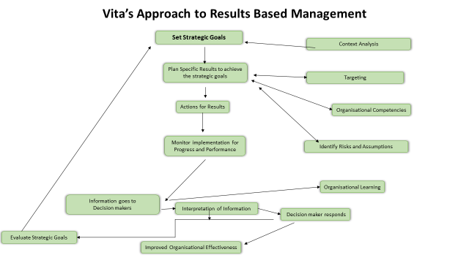

Crosscutting Issues
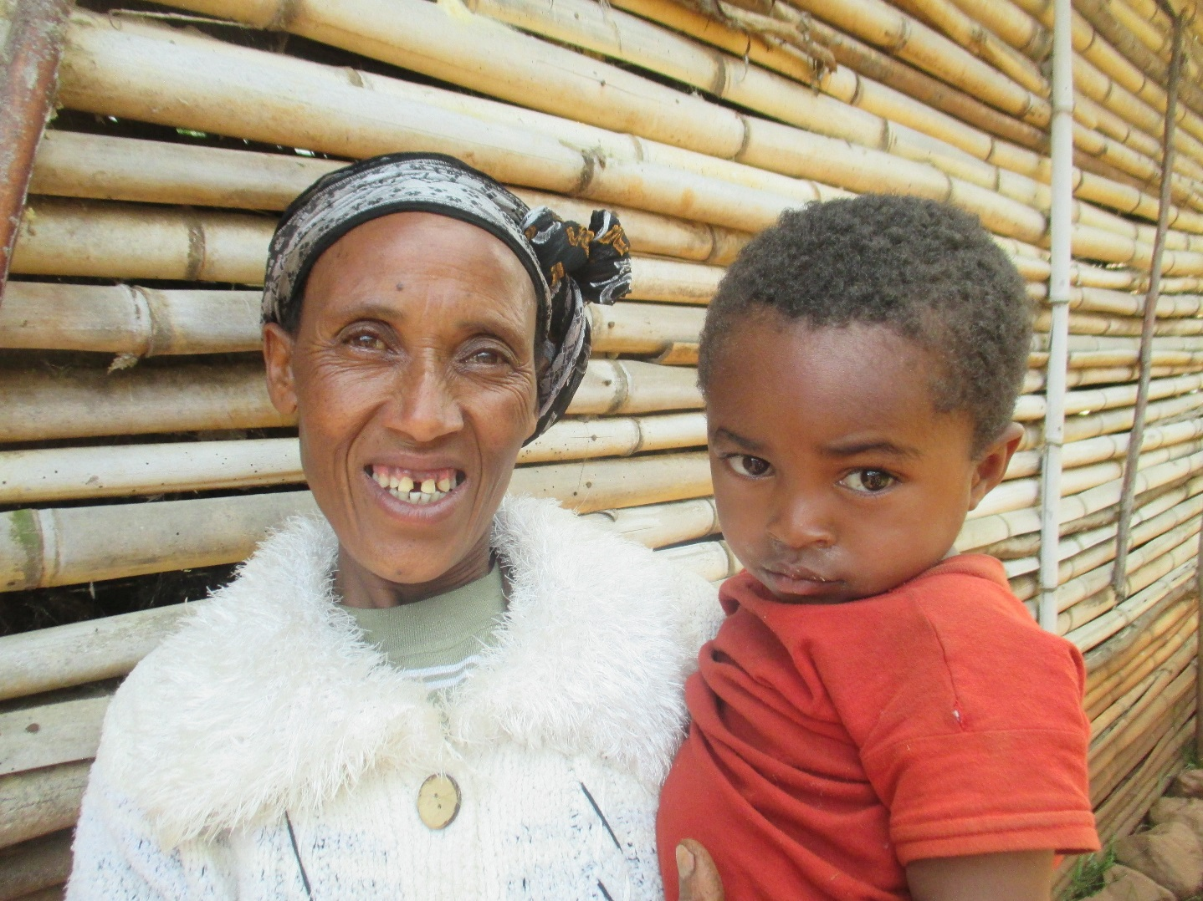
Gender

Gender is a key consideration for Vita, at both organisational and programme level. Vita recognises the different practical and strategic needs of men and women and thus we recognise the need for customised approaches to address the different needs of society. Within our programmes we understand the critical role women play in improving their own livelihoods and the importance of Vita’s approach in meeting the practical and strategic needs of women in fulfilling this role. In supporting the achievement of gender equality through intervention consideration, design, implementation, and monitoring and evaluation, we strive to ensure that gender is fully considered and mainstreamed throughout our work and the organisation as a whole.

Climate change
Climate Change is increasingly impacting on countries across sub Saharan African with some regions of most African countries experiencing on-going drought, coupled with erratic and unpredictable weather patterns. The ability for Vita to develop interventions that are climate resilience/adaptive and can mitigate climate change must be a consideration in future project design with a strong focus on climate smart agriculture. Climate change awareness as evidenced through COP21 indicates an urgency to tackle the issues through both mitigation and adaption. This awareness is being reflected in increased donor and country policy and strategies, analysis, donor funding and initiatives (e.g. Irish Aid climate platform).

Governance and Human Rights
Vita works in country contexts that preclude civil society organisations and NGOs from engaging formally in advocacy around governance and human rights. At the programme level, Vita will continue to promote processes and methodologies (such as CLTS and Farmers Advisory Service extension) which promote participation of communities in their own development, and respect for human rights, particularly the rights of women and children to adequate services and resources.
Vita will take cognisance of in-country human rights issues in programme countries and will take appropriate precautions and mitigating actions where external factors relating to human rights and governance impose critical risks to programme delivery, staff safety, impact and sustainability.
Vita will avail of relationships with government partners, where possible, to promote engagement with international bodies that promote and defend human rights.
HIV/AIDS and Reproductive Health
Through the CLTS methodology, Vita will engage, at a level appropriate to the risk profile of communities and available resources, in awareness raising of communities to instigate behaviour change around reproductive health including mitigation of exposure to HIV/AIDS.

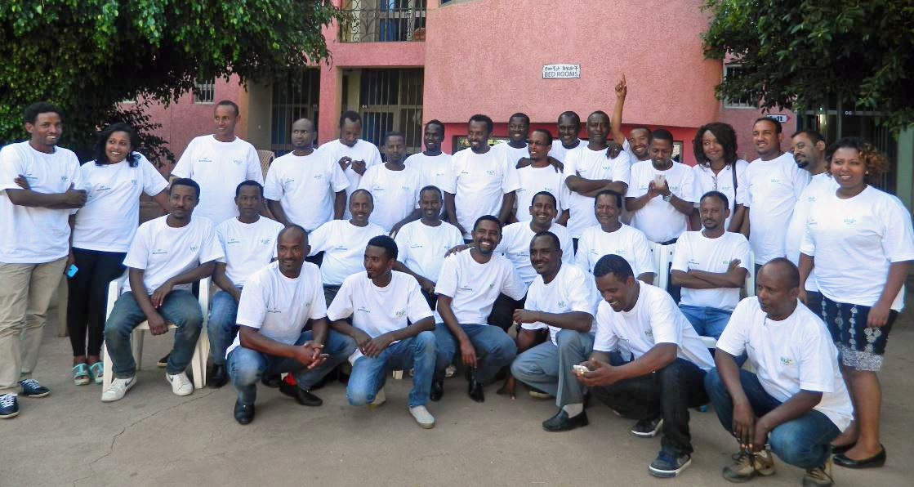

- Developing the Organisation

We will continue to strengthen our organisational capability to ensure the long-term quality of our work as well as to optimise our potential for scaling and influence. Over the period of this plan we will expand our, recently-launched, Vita Green Impact Fund (VGIF), which is a social investment initiative that will generate investment funds for the provision of improved cook stoves, clean water, solar lights and sustainable tree planting schemes. We believe the VGIF represents a sustainable, innovative, “next generation” model of development that brings benefits to the rural communities with which we work, climate change benefits for the planet and also promotes wider climate-friendly development practice. We will also continue to support the on- going expansion of the Irish Potato Coalition into seven countries in eastern Africa.

Our Organisational Objectives

Vita is a relatively small international development agency that has established a niche role in development. This role has enabled tens of thousands of rural households in Africa to build sustainable livelihoods. We believe that our small size does not preclude us from being ambitious in terms of achieving far-reaching strategic objectives through processes of scaling-up, policy influence and multi-country impact particularly as it pertains to climate change mitigation.

In order to achieve our objectives, we are committed to ensuring that Vita has the necessary systems and competencies at all levels of the organisation.

Objective 1
To become a leading international development agency in using climate finance to fight hunger and climate change

Objective 2
To build core competence and organisational systems to enable innovative programming and strategic impact

Our Organisational Strategies
In order to ensure that Vita has the capacity to fulfil our two organisational objectives, we will pursue three strategies that are focused on broadening Vita’s funding sources, accessing and utilising new technologies and strengthening the organisation.
- Broader organisational collaboration focused on sustainable financing and leadership in international development
Vita will use the Vita Green Impact Fund as a springboard to widen collaboration with like-minded philanthropic, religious, social impact investment and commercial organisations to expand the model of carbon-based financing developed by the Fund.
- Build the organisation’s data collection, analysis and learning systems, core competence and accountability to support wider influence
Vita will work to rapidly upgrade our Results Based Management Systems and our ability to collect and analyse our development results so that we can continually improve delivery of our programmes as well as being better able to leverage our knowledge to influence wider development policy and practice.
- Build and maintain the human resource capacity of the organisation
We will continue to strengthen the capacity of key staff throughout the organisation and will support further training, including supporting relevant further education. It is our recruitment policy to ensure that any new staff have the skills, or potential to develop the skills, to serve Vita optimally. We are also committed to advancing gender equality amongst our staff at all levels of the organisation and we will continue to apply a gender-sensitive approach to our work as set out in our gender policy. In regards to Vita’s overarching core competencies, our key focus is set out in the table below:

Core Competencies
Subject matter expertise in CLTS and community led development including for household energy and agriculture.
Subject matter expertise in potato technologies and potato sector development
Specialist expertise in carbon finance including accreditation, project development

Partner Competencies
Teagasc – Knowledge Backed Agriculture including potato, dairy, knowledge transfer, research-extension linkage
CO2Balance – carbon accreditation and trading
CLTS Foundation – Community Led Total Sanitation

Programming Capabilities
Integrated and responsive programme strategy allows for innovation in project design, aimed at improved quality of rural livelihoods in Ethiopia and Eritrea through enhanced agricultural and environmental practices.
Capacity for replication and influence on government practice arising from national ownership and high levels of government and partner support.
Strong accountability to beneficiary communities, host governments and to donors, underpinned by robust and flexible implementation arrangements.
Excellent relationship management with partner and government offices so as to maximise local ownership and leveraging of extension resources at community level.
Innovation and the ability to create platforms and initiatives that can benefit the development sector (potato coalition, impact fund, Teagasc-NGO platform).
Ability to effect change at community level as the direct result of appropriate technologies and interventions applied by Vita.
Ability to engage and leverage the resources of partners in project implementation both in Ireland an in country (Teagasc, Irish industry partners, local Ministries of Agriculture, local Women’s Groups).

Governance, Policies and Funding

During 2016 a governance review exercise was initiated at both board and management level under the direction of the Chairman of the Vita Board. This review benchmarks Vita’s current governance systems and practices against what is recognised as best practice corporate governance for a charity in Ireland, including the legal and regulatory framework for companies and charities. From this review, Vita will complete a governance framework before the end of 2016 and the Vita Board will fulfil its mandate according to this new framework for the 2016-2020 period.

Policies

To guide its ongoing programme work Vita has developed a set of policy documents over the years, which it updates on an ongoing basis, according to a perceived need. The key policy documents include:

- Monitoring and Evaluation Policy
- Targeting Policy
- Partnership Policy
- Food Security (to be written in 2017)
- Climate Change (to be written in 2017)

In addition, we have a set of policies that are applied throughout the organisation. They are:

- Gender Policy
- Child Protection Policy
- Dóchas Code on Images and Messages
- Health and Safety Policy
- Value for Money Policy
- Dignity at Work Policy
- Data Protection Policy
- Conflict of Interest Policy

The Vita Board will annually review the policy register, ensure compliance at management level of all policies as well as revise existing policies or introduce new policies where appropriate. Vita places great importance in the place of accountability as one of its key values. Therefore, for the purpose of this plan, key considerations pertaining to Vita’s ongoing accountability are set out in more detail below.

- Risk Policy
Vita’s Audit Finance Governance board sub-committee (AFG) is mandated by the board to review and report on risk management. Vita maintains an extensive Organisational Risk Register, which is reviewed annually to identify significant or critical risks requiring mitigating action as part of the annual business plan. The two programme countries also select significant or critical risks from the risk register in their annual business plan and conduct quarterly reviews of these, reporting back to the Head Office, if significant issues arise.
The two countries in which Vita operates present very challenging operating environments and so the AFG takes cognisance of contextual risks for Vita at both Head Office and country levels. Vita will also ensure that country risk is given a strong focus in developing the country strategies for Eritrea and Ethiopia. The country risk registers will be reviewed annually and risk mitigation measures will be included in annual country business plans, which will be reviewed by the Dublin office and referred to the AFG.

- Finance Policy

Vita will continue to focus on strengthening the organisation’s financial systems, with a view to ensuring its long term viability as a robust and independently thinking NGO. The following are key strategies:
- Reserves will be kept at a level so as to ensure compliance with the reserves policy at all times
- Dependency on any one donor will be maintained below 50%
- Commitments to co-finance donor funding to be minimised to avoid any risk of depletion of reserves
- Unrestricted income to restricted donor income will be maintained above 15%
- Fundraising income to Cost ratio will be maintained above 3:1 with a target of 5:1

- Audit Policy
We will maintain a systematic approach to Vita’s internal audit function. The internal audit will particularly focus on the efficacy of the policies, procedures, and controls in place. A detailed report will be prepared for each internal audit, and disseminated with the management teams in both the country office and Dublin, as well as with the AFG members. Issues and action points resulting from the internal audits will be tracked and followed up on an ongoing basis for implementation.

Vita’s consolidated organisational accounts are audited externally on an annual basis and our European Union-funded projects are also audited annually. A government-sanctioned audit firm will be engaged to perform the external audit for Vita Ethiopia’s annual financial statements. Vita’s auditors in Eritrea will be amongst the largest and most reputable audit firms in the country.

Funding Strategies

Vita aims to expand total programme funding from €4m to €6m between 2016 and 2020 with a new focus on developing a third major institutional donor alongside Irish Aid and the European Union (DEVCO). We will seek to engage with DFID in relation to Eritrea and with USAID in relation to Ethiopia. In doing so, we hope that Vita’s recent registration in the U.K. and the USA will support our efforts. Vita is already engaged in fundraising in both countries. In addition, we will also seek to build on new consortia and partnership funding arrangements with Gorta SHA, IDE USA, Concern Worldwide, AFAP Australia and others.
In relation to unrestricted income, we will seek a 33% increase from €750,000 to €1m between 2016 and 2020. The focus will be on UK and US markets, as well as on new partners such as the Catholic Church congregations and parishes, Irish Diaspora and environment-focused philanthropy. The unique selling point that Vita will seek to exploit is the climate change mitigation and carbon saving, which emerges from our work in combating hunger and poverty. We will employ one part-time person in the UK to drive fundraising and develop stakeholder engagements and will look towards the establishment of a similar role in the US, if the evidence from the US supports it.
Vita has developed a detailed business plan and investment memorandum for the VGIF and we will implement these plans as a central aspect of the fundraising strategy. Thus, we will give the Vita Green Impact Fund (VGIF) a very strong focus in 2016 and 2017 in order to complete Phase 1 (€2m funding) and then focus our efforts on delivering Phase 2 (€20m funding). This will require a broadening of the investment market to at least four overseas countries in addition to Ireland. We also expect to generate new unrestricted income streams of €1m annually from the VGIF.
With the VGIF as a starting point, Vita will also look at opportunities to become a direct provider of products and services through partnership with agri-food and other corporate players, and possibly through direct investment.

Our two key funding strategies through which Vita plans to expand its funding base as well as increase its overall funding are:

- In Ireland, grow total programme funding to €6million with unrestricted income reaching €1million annually and unrestricted reserves reaching €1 million.
- In Ireland, UK, US, Italy and Australia, build donor partnerships focused on Green Impact Fund to help raise €20 million.

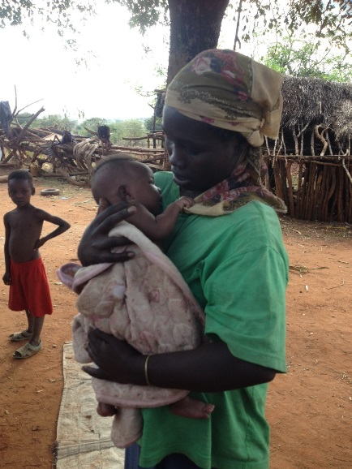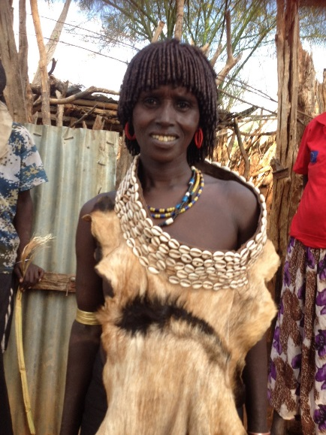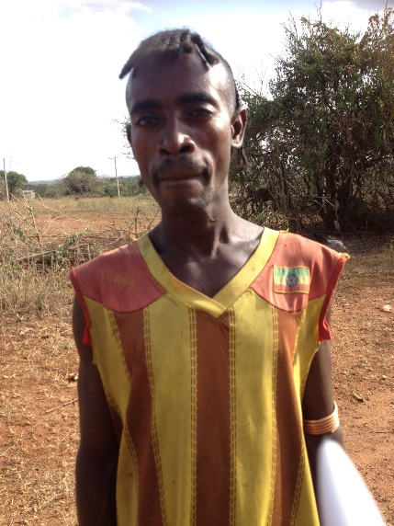

ANNEX 1
Programme, Funding and Organisational Plans 2016-2020 - Key Measurables

Programme Plan
Vita programmes are possible because its ability to source major programme funding. To date this has primarily been Irish Aid (both IA civil society funding and the Irish embassy in Ethiopia) and the EU, with the Vita Green Impact Fund now forming a third funding source. For future funding projections from Impact Fund 2, a very conservative estimate of €4m for Vita programmes is assumed although our target is €20m.
Vita expects to establish a fourth funding source in the 2016-2020 period and to create a more balanced funding base for the organisation. This is most likely to arise in the context of Eritrea where increasingly donor agencies and foundations are looking at engaging there. As Vita is effectively the only NGO operating in Eritrea, other NGOs, such as Gorta SHA have to work through Vita is they wish to operate there. This creates new programme funding opportunities for Vita.
Co-financing for our programmes normally comes from micro grants, NGO partners (AFAP, Gorta/SHA), and cross programme co-financing. Cross programme co-financing occurs when one core programme dovetails into another for some work and each effectively co-finances the other. Into the future this will occur particularly where Impact Fund work overlaps with EU or Irish Aid work. Overall 20% on average is required to co-finance our programmes.
Planned funding for 2016-2020 is €4m in 2016 rising to €7m in 2020. The sources of funding are shown in the chart below.

Key Targets
- 200,000 people with improved nutrition and greater food security
- 500,000 people with sustainable cooking energy and lighting
- 700,000 people enjoying improved health through access to clean energy, clean water and improved nutrition
- 1 million tonnes CO2 emission savings per annum by 2020 (1.4 % of Ireland’s total emissions)
- 500,000 people with sustainable access to clean drinking water 100,000 households with increased household assets and greater control of their own resources.

Funding Sources
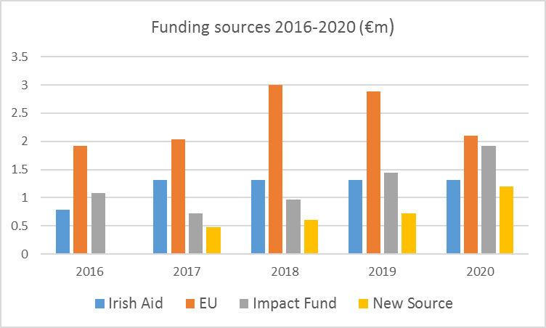

Indicative programme funding 2016-2020 (€ million)
 | 2016 | 2017 | 2018 | 2019 | 2020
Ethiopia
Irish Aid Civil Society (2016) | 0.20
Irish Aid Civil Society (2017-2021) |  | 0.50 | 0.50 | 0.50 | 0.50
Irish Aid (Embassy) | 0.30 | 0.30 | 0.30 | 0.30 | 0.30
EU SHARE (resilience project) | 1.20
EU RESET (resilience project) | 0.20 | 1.50 | 1.50 | 1.30
EU - unidentified |  |  | 0.30 | 0.40 | 1.00
Impact Fund I - loans | 0.20 | 0.40
Impact Fund 2 - loans |  |  | 0.30 | 0.50 | 0.80
Subtotal | 2.10 | 2.70 | 2.90 | 3.00 | 2.60
Eritrea
Irish Aid (Civil Society) | 0.15
Irish Aid Civil Society (2017-2021) |  | 0.30 | 0.30 | 0.03 | 0.30
EU Stoves project | 0.15
EU dairy & veg. associations | 0.05 | 0.20 | 0.2 | 0.2
EU - unsecured identified |  |  | 0.5 | 0.5 | 0.75
Impact Fund I - loans | 0.60 | 0.30
Impact Fund 2 - loans |  |  | 0.3 | 0.5 | 0.50
New Institutional Donor |  | 0.40 | 0.5 | 0.6 | 1.00
Subtotal | 0.95 | 1.20 | 1.8 | 2.1 | 2.55
Other VGIF Countries
Impact Fund I - loans | 0.10
Impact Fund 2 - loans |  |  | 0.20 | 0.20 | 0.30
Subtotal | 0.10 |  | 0.20 | 0.20 | 0.30
Subtotal programme funding | 3.15 | 3.90 | 4.90 | 5.30 | 5.45
Co-Financing 20% | 0.63 | 0.76 | 0.98 | 1.06 | 1.09
Total Programme | 3.78 | 4.66 | 5.88 | 6.36 | 6.54

Programme Locations

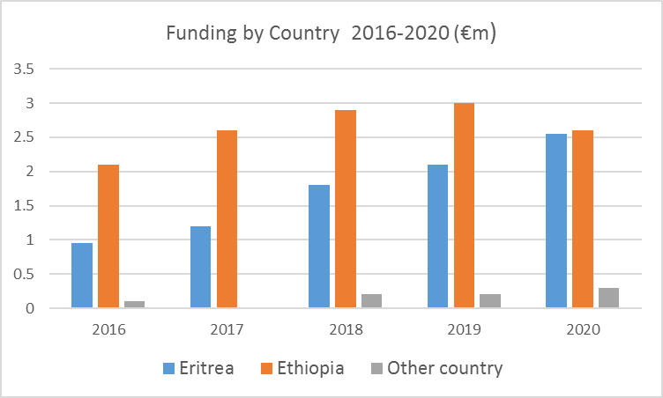

Organisational Plan
We will strengthen the capacity of the organisation by developing new organisational structures that meet growing demands from initiatives such as the Vita Green Impact Fund (VGIF), increased focus on results based management (RBM) and on our new goal of scaling and influence.
The Vita Green Impact Fund will build capacity in-country to undertake all accreditation procedures by 2018 and will look to develop competence in the selling of voluntary carbon credits.
To strengthen our results based management system we will create a new position that will focus on learning and RBM. We will also undertake to upskill staff in the programme countries through ongoing training.
ANNEX 2 - Vita’s Alignment with the Global Goals for Sustainable Development
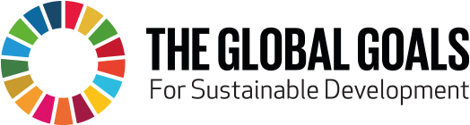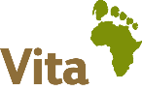

Household Hunger | Household Energy | Household Water & Sanitation | Climate Change
Global Goal No 2  By 2030, end hunger, achieve food security, and improved nutrition and promote sustainable agriculture | Global Goal No 7 – Target 7.1  By 2030, ensure universal access to affordable, reliable and modern energy services  Global Goal No.3 – Target 3.9  By 2030, substantially reduce the number of deaths and illness from air & water pollution | Global Goal No. 6 – Target 6.1  By 2030, universal access to safe and affordable drinking water for all | Global Goal No.13  Implement commitment by developed country parties to UNFCC to address needs of developing countries for mitigation  Global Goal No 13  Take urgent action to combat climate change and its impacts
Impact Metrics
0.5 million people with reduced hunger and with sustainable access to food security, agricultural technologies and adequate nutrition | 1 million people with access to affordable and renewable energy for cooking and lighting  2 million trees planted | 2 million people with access to safe and affordable drinking water  Reduction of illness from air pollution | €20 million raised in innovative and sustainable financing for climate mitigation  2 million tonnes carbon emission reductions
Verification
Research studies  Government evaluations  Independent donor evaluations | Gold Standard accreditation  Government evaluations  Independent donor evaluations | Gold Standard accreditation  Research studies  Independent donor evaluations | Local independent auditors  International Auditors  Independent donor evaluations

